# EXP NO: 01 Intro to Digital Forensics NAME : ADHIYAN PERIYAR R P DATE: 10/07/2025 ROLL NO : 231901002

**AIM:**

Learn about digital forensics and related processes and experiment with a practical example.

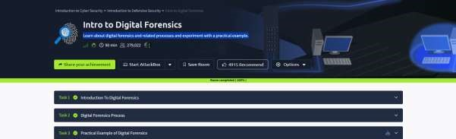

# Task 1 : Introduction To Digital Forensics

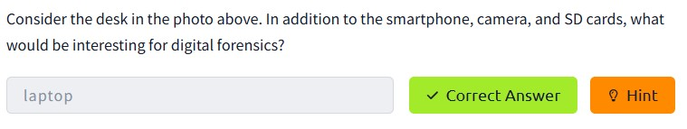

# Task 2 : Digital Forensics Process

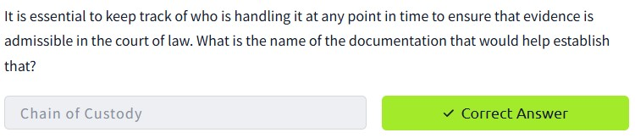

# Task 3 : Practical Example of Digital Forensics

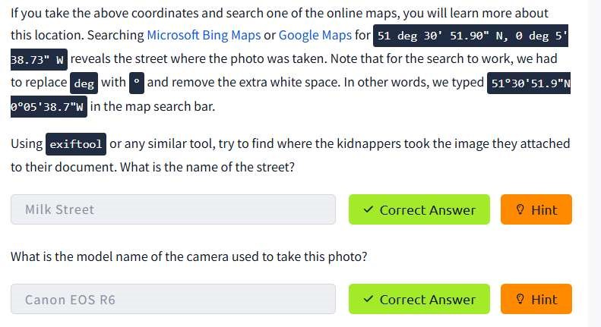

**RESULT :**

Intro to Digital Forensicsis successfully completed in tryhackme platform